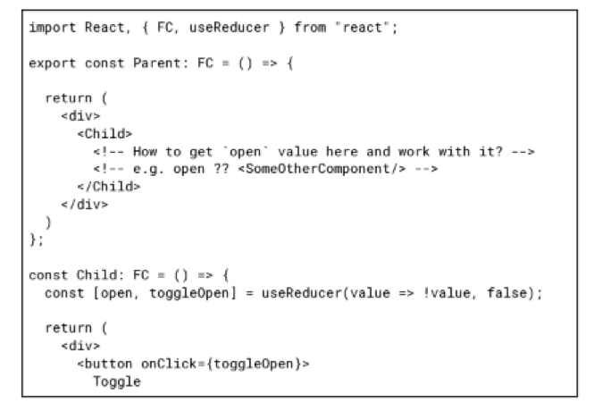

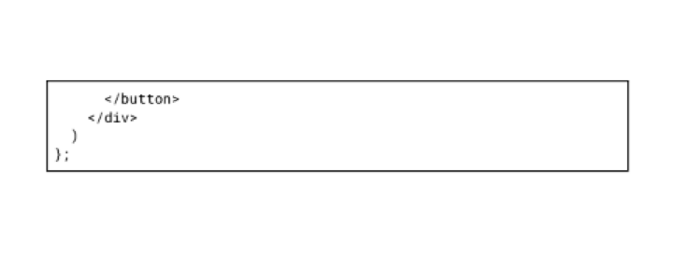

Review following code snippet and answer questions:

1. What options do we have to get `open` value in Parent component?
2. What benefits and drawbacks of each method?

1. React works on a one-way data flow. Data is passed from the parent component to the child through props. In this situation,

If we want control and create actions this prop we can call children(toggle) function in the parent component and after it we can create this structure

<Child>

{(toggle) => …..}

</Child>

and use it.

Also we can rewrite the useReducer hook on the consumed Parent and pass state change function as properties on the Child. We can change the rendering logic in the Child component by conditional rendering, depending on the first parameter of the useReducer hook.

2. This method allows you to split the components into container and presentation components, where container components store the logic and control the presentational display logic. This makes the code easy to understand and expand. One of the main drawbacks is the increasing understanding of our code. Secondly, the nesting of our project also increased.